Johnny’s Community Run

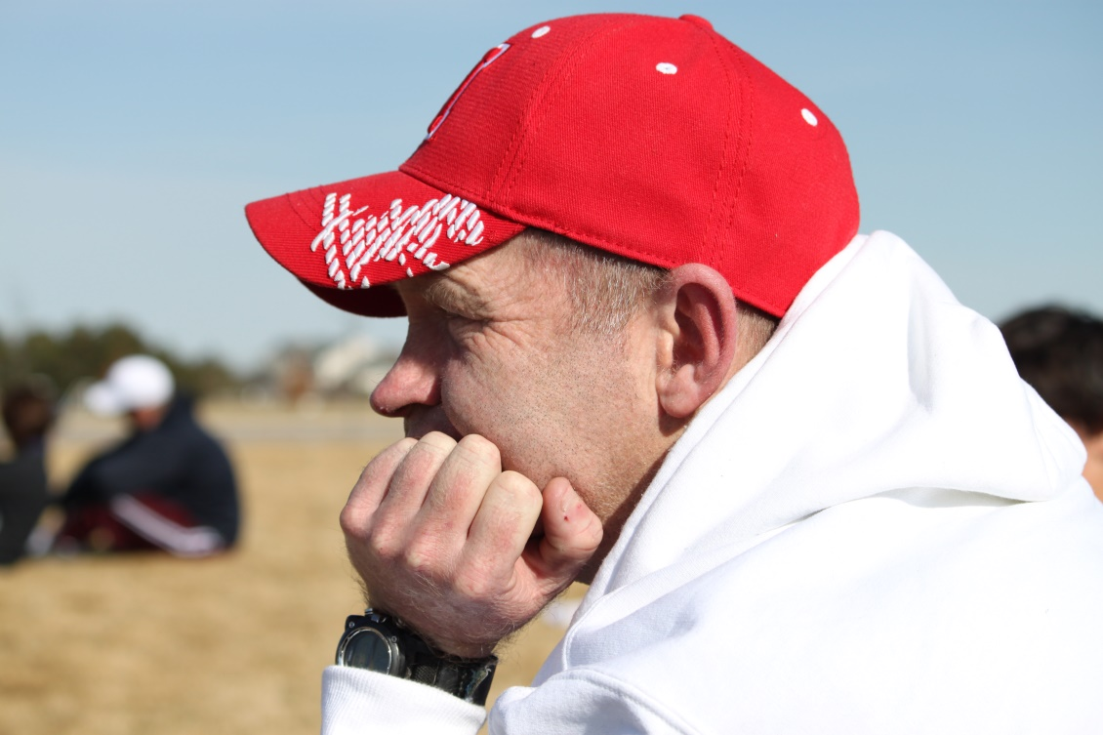

A 5K community run/walk designed to continue John “Johnny” Jacoby’s unselfish life of service to the Windsor community.
The Race will be held on Saturday, April 29, 2017, starting at 9:00 am at Windsor Lake-Boardwalk Park.

Register at: www.JohnnysCommunityRun.com
Early Registration, Adult (received by April 17) is $25.00
Early Registration, Child (12 and under) (received by April 17) is $15.00
Late and Race Day Registration, Adult (after April 17) is $30.00*
Late and Race Day Registration, Child (after April 17) is $20.00*

Register early to receive your free event t-shirt.
Early Registration pick up on April 27 at Vineyard of the Rockies-Windsor Campus:
1450 Westwood Drive, Windsor 12pm-6pm.
*T-shirts are not available with late registration.
Race day registration opens at 7:30 am and closes at 8:30 am at Windsor Lake-Boardwalk Park.
Post race refreshments will be available.

Proceeds from the race will be distributed in honor of John Jacoby to 28 Hours of Hope and the Johnny Jacoby Scholarship fund for Windsor High School Students.
For individual or corporate sponsorship opportunities, please email us at info@johnnyscommunityrun.com. Donations accepted at Bank of Colorado-Windsor and online through Eventbrite.com. Johnny’s Community is a 501(c)3 organization.

